Nama : Ricy Rifani Putra
Nim : A11.2025.16464
Matery : Tree

Output
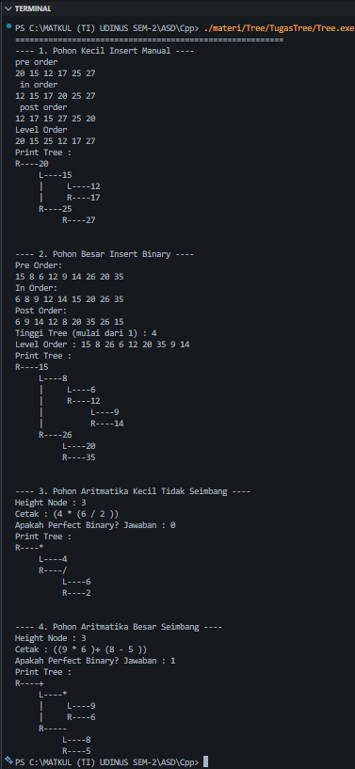

Source Code
// Name : Ricy Rifani Putra
// Nim : A11.2025.16464
// Matery : Tree
#include<iostream>
using namespace std;

class Node{
public:
int data;
Node *left;
Node *right;

Node(){
data = 0;
left = right = NULL;
}
Node(int data){
this->data = data;
left = right = NULL;
}
};

class NodeAritmatika{
public:
char data = ' ';
NodeAritmatika *left = NULL;
NodeAritmatika *right = NULL;

NodeAritmatika(char data){
this->data = data;
}
};

class Tree{
public:
Node *root;

Node *insertBinaryRoot(Node *root, int nilai);
void preOrder(Node *root);
void inOrder(Node *root);
void postOrder(Node *root);
void printCurrentLevel(Node *root, int level);
void levelOrder(Node *root);
int heightNode(Node *root);
int heightNodeAritmatika(NodeAritmatika *root);
void inOrderAritmatika(NodeAritmatika *root);
bool isPerfectBinaryArit(NodeAritmatika *root, int tinggi, int level);
void printTree(Node *root, string indent = "", bool last = true);
void printTreeArit(NodeAritmatika *root, string indent = "", bool last = true);
};

int main()
{
// =========================================================
// 1. Pohon angka kecil - Insert Manual
cout << "=========================================================\n";
cout << "---- 1. Pohon Kecil Insert Manual ----\n";
Node *root = new Node(20);
root->left = new Node(15);
root->left->right = new Node(17);
root->left->left = new Node(12);
root->right = new Node(25);
root->right->right = new Node(27);
Tree pohon;

cout << "pre order\n";
pohon.preOrder(root);
// 20-15-12-17-25-27
cout << "\n in order\n";
pohon.inOrder(root);
// 12-15-17-20-25-27
cout << "\n post order\n";
pohon.postOrder(root);
cout << "\nLevel Order\n";
pohon.levelOrder(root);

cout << endl;
cout << "Print Tree :\n";
pohon.printTree(root);

// 2. Pohon angka besar - Insert Binary
cout << "\n\n---- 2. Pohon Besar Insert Binary ----\n";
Node *root1 = NULL;
Tree T;
root1 = T.insertBinaryRoot(root1, 15);
root1 = T.insertBinaryRoot(root1, 26);
root1 = T.insertBinaryRoot(root1, 8);
root1 = T.insertBinaryRoot(root1, 12);
root1 = T.insertBinaryRoot(root1, 20);
root1 = T.insertBinaryRoot(root1, 6);
root1 = T.insertBinaryRoot(root1, 9);
root1 = T.insertBinaryRoot(root1, 14);
root1 = T.insertBinaryRoot(root1, 35);

cout << "Pre Order: " << endl;
T.preOrder(root1);
cout << "\nIn Order: " << endl;
T.inOrder(root1);
cout << "\nPost Order: " << endl;
T.postOrder(root1);

int tinggi;
tinggi = T.heightNode(root1);
cout << "\nTinggi Tree (mulai dari 1) : " << tinggi << endl;
cout << "Level Order : ";
T.levelOrder(root1);
cout << endl;
cout << "Print Tree :\n";
T.printTree(root1);

// 3. Pohon Aritmatika kecil - Tidak Seimbang
cout << "\n\n---- 3. Pohon Aritmatika Kecil Tidak Seimbang ----\n";
NodeAritmatika *akar = new NodeAritmatika('*');
akar->left = new NodeAritmatika('4');
akar->right = new NodeAritmatika('/');
akar->right->left = new NodeAritmatika('6');
akar->right->right = new NodeAritmatika('2');
Tree witArit;

cout << "Height Node : " << witArit.heightNodeAritmatika(akar);
cout << "\nCetak : "; // (4*(6/2))
witArit.inOrderAritmatika(akar);
cout << endl;
cout << "Apakah Perfect Binary? Jawaban : " << witArit.isPerfectBinaryArit(akar, witArit.heightNodeAritmatika(akar), 0) << endl;
cout << "Print Tree :\n";
witArit.printTreeArit(akar);

// 4. Pohon Aritmatika besar - Seimbang
cout << "\n\n---- 4. Pohon Aritmatika Besar Seimbang ----\n";
NodeAritmatika *akar2 = new NodeAritmatika('+');
akar2->left = new NodeAritmatika('*');
akar2->left->left = new NodeAritmatika('9');
akar2->left->right = new NodeAritmatika('6');
akar2->right = new NodeAritmatika('-');
akar2->right->left = new NodeAritmatika('8');
akar2->right->right = new NodeAritmatika('5');
Tree witArit2;

cout << "Height Node : " << witArit2.heightNodeAritmatika(akar2);
cout << "\nCetak : "; // ((9*6)+(8-5))
witArit2.inOrderAritmatika(akar2);
cout << endl;
cout << "Apakah Perfect Binary? Jawaban : " << witArit2.isPerfectBinaryArit(akar2, witArit2.heightNodeAritmatika(akar2), 0) << endl;
cout << "Print Tree :\n";
witArit2.printTreeArit(akar2);

return 0;
}

void Tree::preOrder(Node *root){
if(root != NULL){
cout << root->data << " ";
preOrder(root->left);
preOrder(root->right);
}
}

void Tree::inOrder(Node *root){
if(root != NULL){
inOrder(root->left);
cout << root->data << " ";
inOrder(root->right);
}
}

void Tree::postOrder(Node *root){
if(root != NULL){
postOrder(root->left);
postOrder(root->right);
cout << root->data << " ";
}
}

Node *Tree::insertBinaryRoot(Node *root, int nilai){
if(root == NULL){
root = new Node(nilai);
} else if(nilai < root->data){
root->left = insertBinaryRoot(root->left, nilai);
} else {
root->right = insertBinaryRoot(root->right, nilai);
}
return root;
}

void Tree::printCurrentLevel(Node *root, int level){
if(root != NULL){
if(level == 0){
cout << root->data << " ";
} else if(level > 0){
printCurrentLevel(root->left, level - 1);
printCurrentLevel(root->right, level - 1);
}
}
}

void Tree::levelOrder(Node *root){
int h = heightNode(root);
for(int i = 0; i < h; i++){
printCurrentLevel(root, i);
}
}

int Tree::heightNode(Node *root){
if(root == NULL){
return 0;
} else {
int leftH = heightNode(root->left);
int rightH = heightNode(root->right);
return 1 + max(leftH, rightH);
}
}

int Tree::heightNodeAritmatika(NodeAritmatika *root){
if(root == NULL){
return 0;
} else {
int leftH = heightNodeAritmatika(root->left);
int rightH = heightNodeAritmatika(root->right);
return 1 + max(leftH, rightH);
}
}

void Tree::inOrderAritmatika(NodeAritmatika *root){
if(root != NULL){
if(root->left != NULL && root->right != NULL)
cout << "(";
inOrderAritmatika(root->left);
cout << root->data << " ";
inOrderAritmatika(root->right);
if(root->left != NULL && root->right != NULL)
cout << ")";
}
}

bool Tree::isPerfectBinaryArit(NodeAritmatika *root, int tinggi, int level){
if(root == NULL)
return true;

if(root->left == NULL && root->right == NULL)
return tinggi == level + 1;

if(root->left == NULL || root->right == NULL)
return false;

return isPerfectBinaryArit(root->left, tinggi, level + 1) &&
isPerfectBinaryArit(root->right, tinggi, level + 1);
}

void Tree::printTree(Node *root, string indent, bool last){
if(root != NULL){
cout << indent;
if(last){
cout << "R----";
indent += " ";
} else {
cout << "L----";
indent += "| ";
}
cout << root->data << endl;
printTree(root->left, indent, false);
printTree(root->right, indent, true);
}
}

void Tree::printTreeArit(NodeAritmatika *root, string indent, bool last){
if(root != NULL){
cout << indent;
if(last){
cout << "R----";
indent += " ";
} else {
cout << "L----";
indent += "| ";
}
cout << root->data << endl;
printTreeArit(root->left, indent, false);
printTreeArit(root->right, indent, true);
}
}

